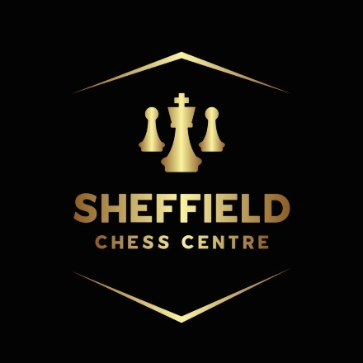
EJCOA NATIONAL YOUTH CHAMPIONSHIPS
SOUTH YORKSHIRE ZONAL – SAT APRIL 20th
Sheffield Chess Centre, 329A Coleford Road, Sheffield, S9 5NF

U20/U18/U16/U14/U12/U10/U8
Ages as of January 1st 2024 as per FIDE rules
Online entry: https://form.jotform.com/240205836984361

Prizes (books / equipment / trophies / chess items / cash) depending on entries.

Round 1: 12pm Round 2: 1:15pm Round 3: 2:30pm
Round 4: 3:45pm Round 5: 5pm

- You may enter more than one Zonal if you wish.
- Entry fee: £20. Players should be ECF Silver members or above (Free Junior Silver membership for the first year). Non-members will need to pay the ECF’s Pay To Play fee.
- Some age group sections may be combined.
- Top boys/girls in each age group qualify for national finals as per EJCOA rules.
- Entries on a first come, first serve basis.
- Some refreshments will be available to purchase on the day.
- Free parking is available on street.
- In all matters the organisers’ decision is final.

Please send details (listed below) to: sheffieldchesscentre@gmail.com
Email entries will be acknowledged to confirm receipt.
Payment may be made by bank transfer to: South Yorkshire Chess, 08-92-99, 67282861. Use player’s full name as payment reference.

-------------------------------------------------------------------------------------------------------------------------------------

Completed entry forms should be sent to: Jonathan Arnott, 9 Ravenscroft Close, Sheffield, S13 8PN.

First Name: _________________ Surname: __________________ DOB (if U18): ____/_____/______
Contact No: ________________________ Email address: _________________________________

Address:__________________________________________________________________________
______________________________________________ Postcode: __________________

Rating: ________________ ECF ID: ________________ Club: ________________

Section choice: U2000 / U1500: __________

Fee paid: £__________ ½ point bye required in round: ___________
Cheques to be made payable to: South Yorkshire Chess

